How to make monetary donations.
- From the BSD Main page, hover the “Departments” header at the top of the page.
- Select “Business Services”.
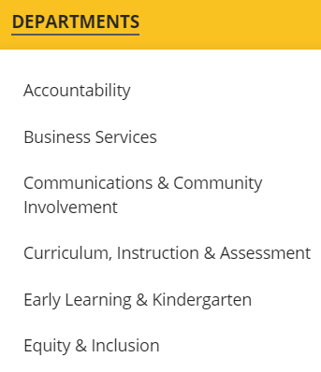
- Expand the section labelled “Donations”.
- Click on the “Donate Here” button.
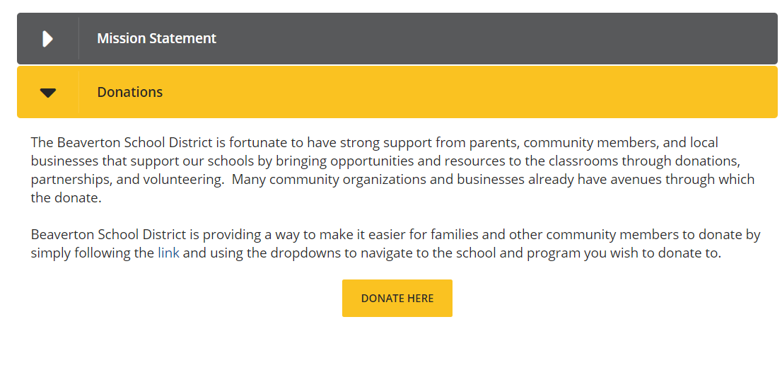

- This will take you to the District’s payment site. 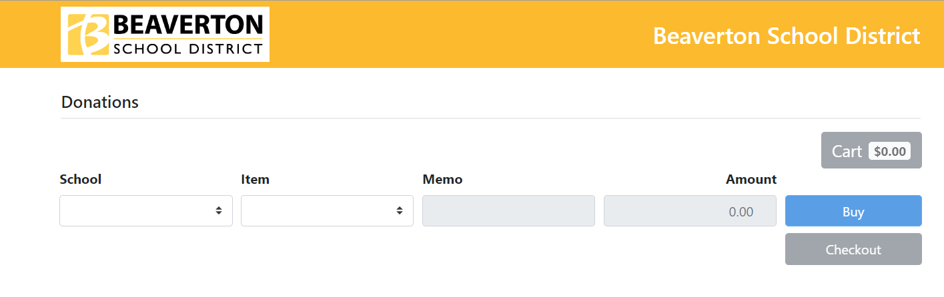
- Click on the “School” drop down and select “Beaverton School District” under the “District Office” option.
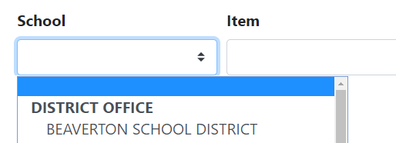
- Select “Nutrition Services Meal Program Donations”.
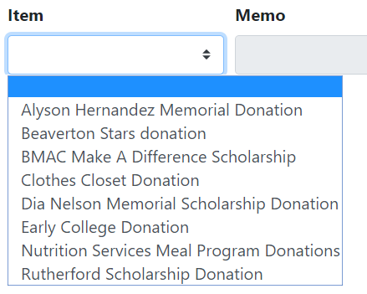

- Enter the amount you would like to donate, and include a Memo, if you would like the funds applied in a specific way.

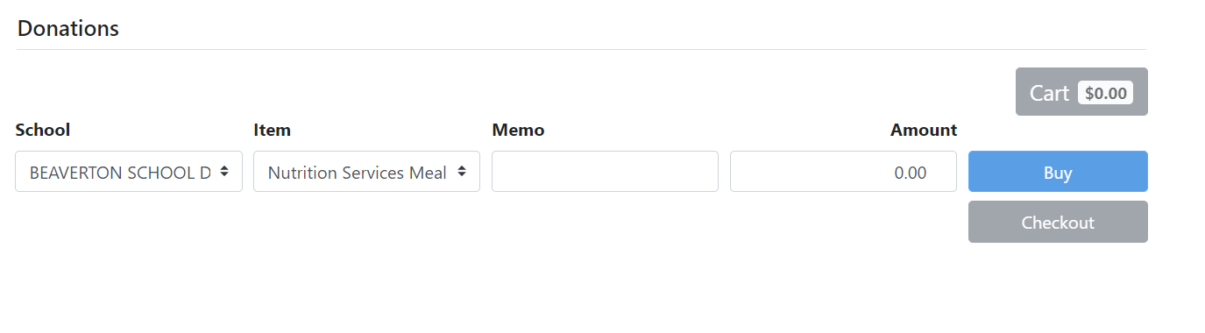

- When the information has been entered in, please select “Checkout” and follow the instructions provided.

